# Shepherd checking celery task log via taskId

Search task from flower UI by taskId.

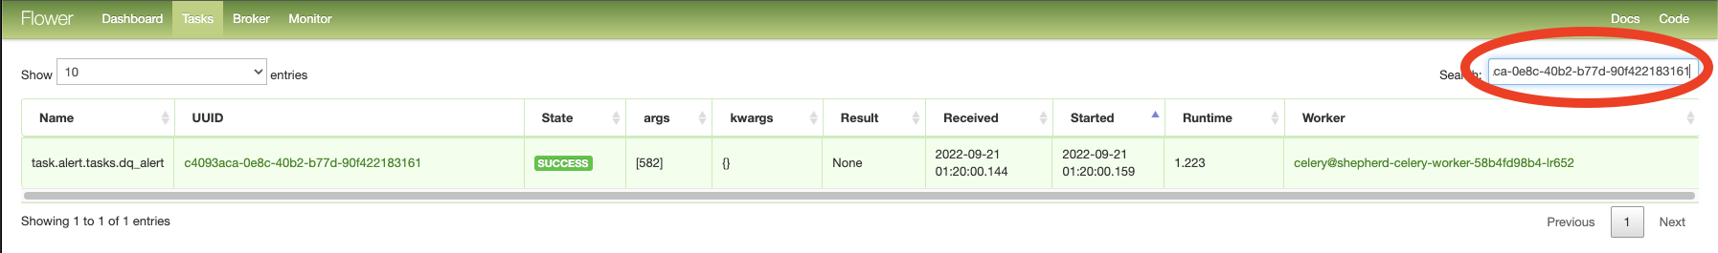

You will get the record of this task. Take the the worker name in Column Worker In this example,  worker is [**shepherd-celery-worker-58b4fd98b4-lr652**](http://shepherd-api-adsshepherd.vip.ebay.com:5555/worker/celery%40shepherd-celery-worker-58b4fd98b4-lr652)

Go to <https://cloud.ebay.com/object/detail/Namespace:shepherd-prod:fcp-prod?source=search#federateddeployment> to find the FD for the worker, here the FD is **shepherd-celery-worker**

Go to <https://cloud.ebay.com/object/detail/FederatedDeployment:shepherd-celery-worker:fcp-prod:shepherd-prod> to find which cluster the worker belong to cluster 40

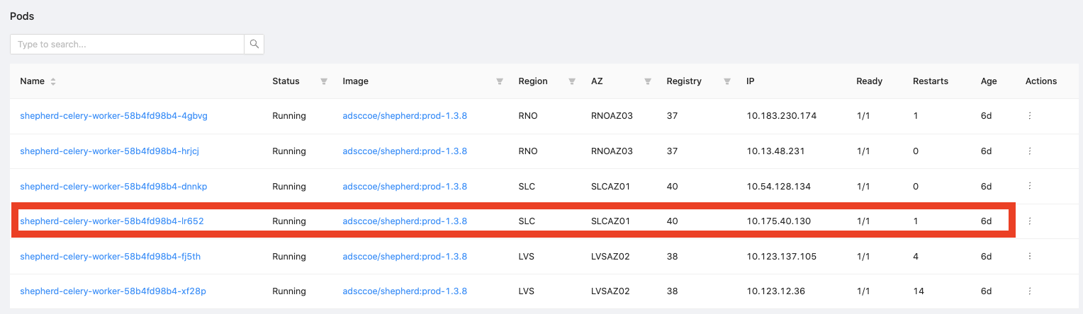

You can check task logs either on Elasticsearch or on log files.

To check logs in Elasticsearch, you can go to Kibana and query for index pattern **shepherd_log_celery_task-\***, more info can be found in Shepherd Logging

To check log files, you can login tess prod env and login the worker and go to path /usr/src/app/data-quality/log, you can find the worker log within 2days there

tess kubectl --cluster=40 -n shepherd-prod exec -it shepherd-celery-worker-58b4fd98b4-lr652 -- /bin/bash

cd /usr/src/app/data-quality/log